Experiment 24: Sharpening of Image using High-Boost Masks
Software / Tools: Python · OpenCV (cv2) · NumPy

AIM
To sharpen an image using a High-Boost filter, which amplifies the original image before subtracting the blurred/low-pass component, giving control over the amount of sharpening (A >= 1).
ALGORITHM
1. Import OpenCV and NumPy.
2. Read the input image.
3. Choose a boost factor A (A >= 1; A = 1 reduces to standard Laplacian sharpening).
4. Build the high-boost kernel [[0,-1,0],[-1,A+4,-1],[0,-1,0]].
5. Apply cv2.filter2D() with this kernel.
6. Display and save the high-boost sharpened image.
PROGRAM (SOURCE CODE)
import cv2
import numpy as np

img = cv2.imread("image.jpg")

A = 1.5 # Boost factor (A >= 1)
kernel = np.array([[0, -1, 0],
[-1, A + 4, -1],
[0, -1, 0]])

sharpened = cv2.filter2D(img, -1, kernel)

cv2.imshow("High-Boost Sharpened", sharpened)
cv2.waitKey(0)
cv2.destroyAllWindows()

OUTPUT
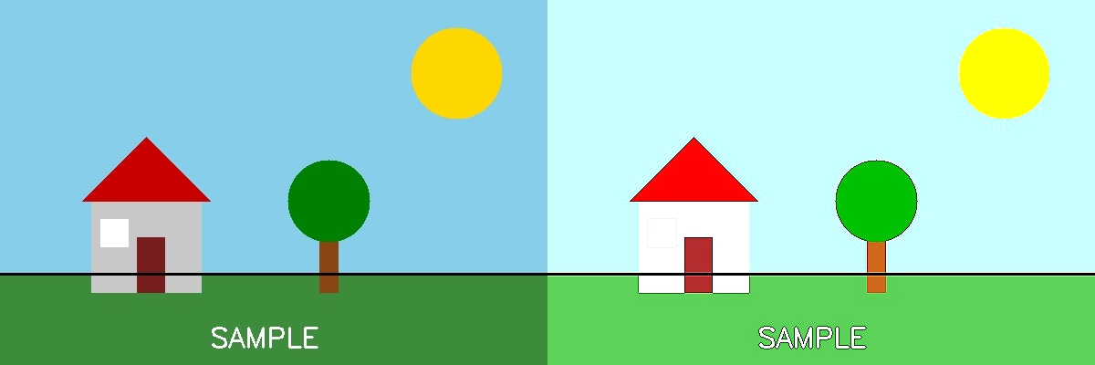
Fig. 24 — Output of Experiment 24: Sharpening of Image using High-Boost Masks.
RESULT
Sharpen an image using a High-Boost filter, which amplifies the original image before subtracting the blurred/low-pass component, giving control over the amount of sharpening (A >= 1) — completed successfully, as demonstrated in the output shown above.

